EXPEREMENT 2

Create a simple cloud software application for Property Buying & Rental process (In Chennai city) using any Cloud Service Provider to demonstrate SaaS include the necessary fields such as Buy, Rent, commercial, Rental Agreement, Rental Agreement, Area, place, Range, property value etc.

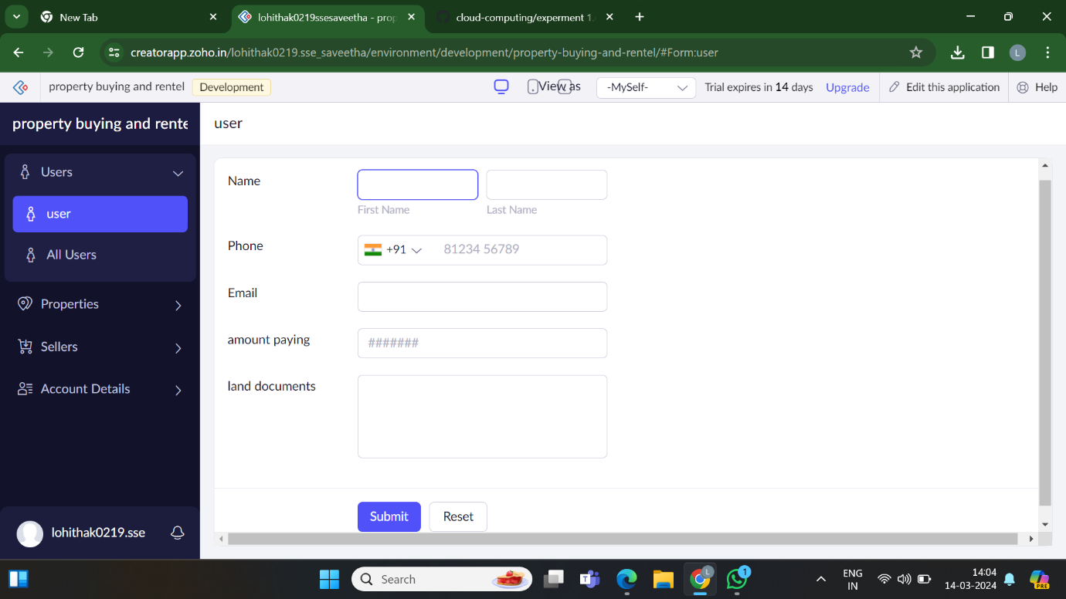

1.create user application

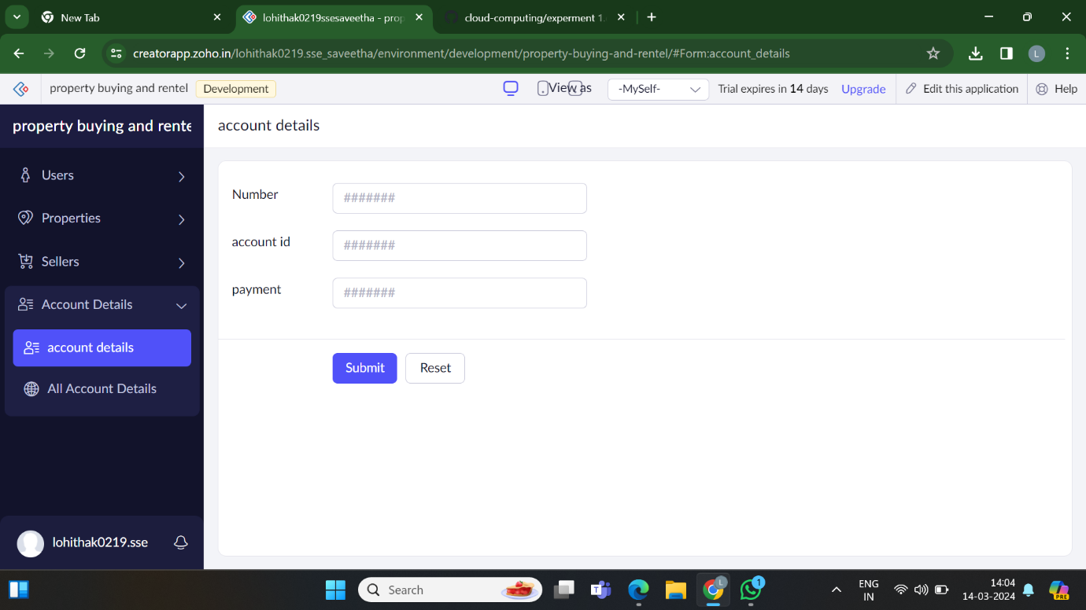

2.create account details application

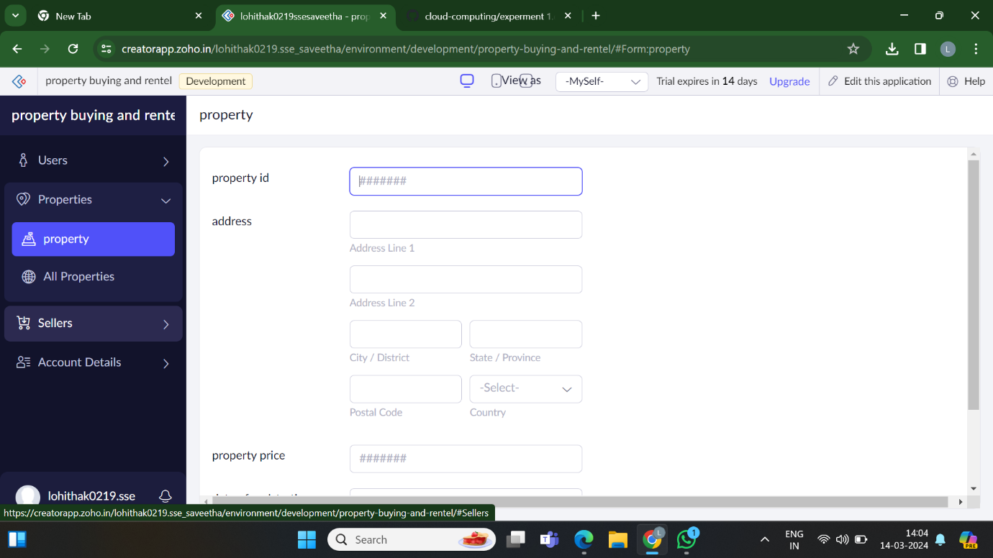

3.create property application

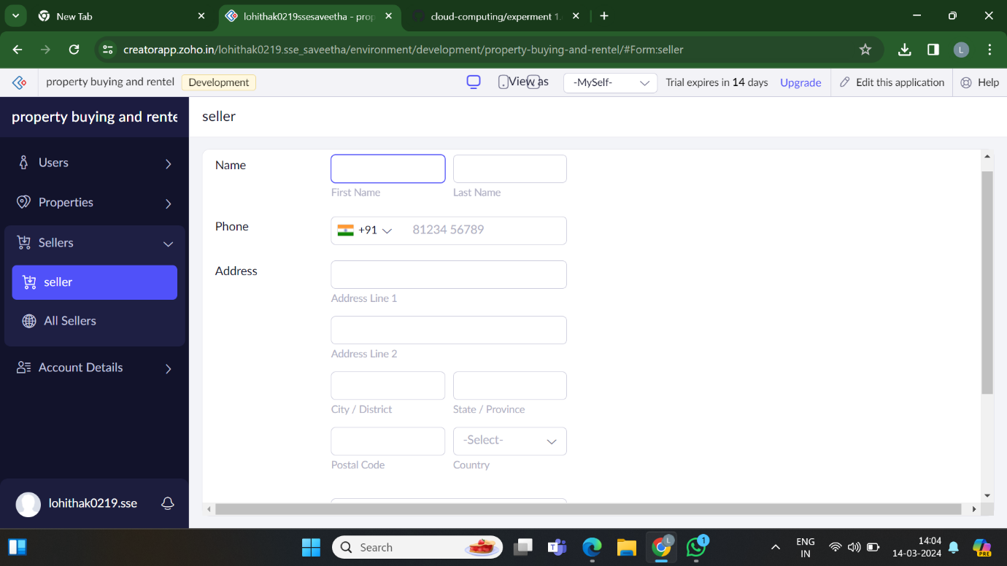

4.create seller application form

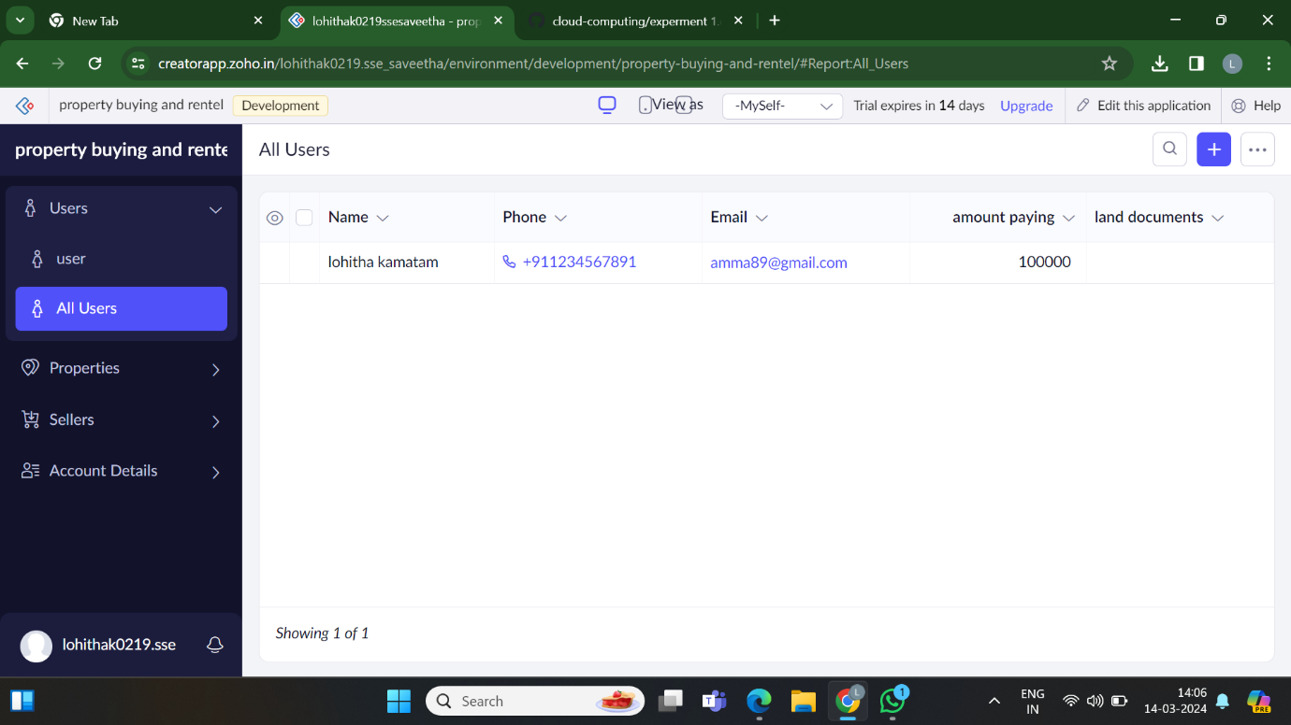

4.shows the required user details